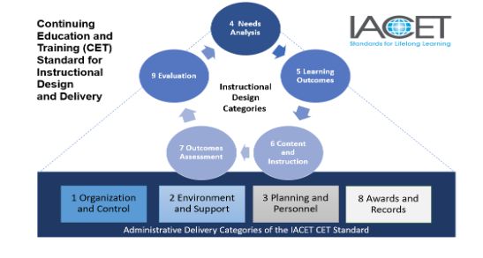
IACET Application Documentation Knowledge Check Case Scenarios

Let Me Tell You Our Story:

Shar is the Learning Manager for The Association of Pet Rock Owners and is submitting the process for Category 1.4. Here is what Shar plans to submit:

“Our company measures the success of our training and development department through course evaluations, revenue generated, and increase in customers. As the IACET compliance officer, I pull together our results, put it in a report, and send it to our CEO.”

- Is this a good process document? Why or why not?
- What evidence may be used?

What Comes First: The Chicken or the Egg?

Caleb is the training coordinator at a manufacturing plant and already has e-mails that they send to notify the learners whether or not they successfully achieved learning outcomes. They don’t have a process documented, they just…well…do it.

- Can Caleb just submit the e-mails when the application asks for a process?
- What can Caleb do if they don’t currently have a process documented?
- Where would Caleb upload the e-mails?

It’s Our Policy:

Ling is the instructional design manager at ABC Learning and works with several independent contractors to develop their online learning. Here is their policy on intellectual property (Category 2.1) .

“As an independent contractor working for ABC Learning, all material you develop for online courses is the property of ABC Learning. In addition, you must request permissions or pay to use others’ copyrighted intellectual property in the development of our online courses.”

- Is this sufficient?
- Why or why not?

